CASE STUDY — ZeroShield.ai
Autonomous Threat Defense & Zero-Trust Infrastructure on AWS
1. Client Overview
ZeroShield.ai is a cybersecurity platform built around three core pillars: Autonomous Threat Defense, Collaborative Intelligence, and Network & Connectivity. The platform delivers real-time, AI-driven threat detection and response capabilities for enterÞprise environments, enabling organisations to proactively identify, contain, and neutralise security incidents before they escalate.
Facing a rapidly evolving threat landscape, ZeroShield.ai required cloud network infrastructure that was not only high-performance and resilient, but also verifiably secure, compliant, and operationally efficient at scale.
2. The Challenge
ZeroShield.ai needed to deploy a production-grade, secure, and compliant network infrastructure on AWS supporting multiple topology designs — including hub-and-spoke, linear, tree, and star configurations — while enforcing a strict zero-trust security posture across all workloads.
Key pain points included:
- No centralised network control plane to manage traffic routing across multiple VPCs and topology configurations.
- Manual security configuration processes creating inconsistency, compliance gaps, and significant operational overhead.
- Absence of automated threat detection and response workflows aligned to their zero-trust model.
- SOC 2 Type II compliance required, with continuous monitoring, auditability, and evidence collection.
- Lack of unified visibility into network-level threats, misconfigurations, and policy violations across environments.
3. The Solution
Kiwi Koru Limited designed and deployed a fully automated, zero-trust network and security architecture on AWS — purpose-built to meet ZeroShield.ai's multi-topology requirements and compliance obligations.
Component | Role in Architecture
Transit Gateway Hub-and-Spoke | Deployed AWS Transit Gateway as the central network hub, connecting multiple VPCs in a hub-and-spoke topology with centralised traffic routing, policy enforcement, and inter-VPC segmentation — with flexibility to extend to linear, tree, and star configurations as the platform scales.
AWS Network Firewall & WAF | Integrated AWS Network Firewall with custom stateful and stateless rule groups to inspect and control east-west and north-south traffic flows. AWS WAF deployed in front of public-facing services with managed rule sets and custom rules to block malicious web traffic and application-layer threats.
Shield Advanced | Enabled AWS Shield Advanced across all public endpoints for DDoS protection with 24/7 access to the AWS DDoS Response Team and detailed attack diagnostics, ensuring service availability during active threat events.
GuardDuty & Security Hub | Activated Amazon GuardDuty for continuous threat intelligence across all accounts, ingesting VPC flow logs, DNS logs, and CloudTrail events. Security Hub configured as the centralised findings aggregator, normalising alerts into a single prioritised view for the security operations team.
IAM Least-Privilege Controls | Designed a comprehensive IAM strategy using role-based access control, service control policies (SCPs), and permission boundaries — enforcing least privilege across all workloads, service accounts, and human identities.
AWS Config Continuous Compliance | Configured AWS Config with managed and custom rules to continuously evaluate resources against ZeroShield.ai's security baselines and SOC 2 requirements. Automated remediation actions set up for critical non-compliant findings.

AWS Services Used:
Transit Gateway | Network Firewall | WAF | Shield Advanced
GuardDuty | Security Hub | IAM | AWS Config

4. What Was Delivered
- Hub-and-spoke VPC network architecture via Transit Gateway, supporting multi-topology configurations (linear, tree, and star).
- AWS Network Firewall with custom stateful and stateless rule groups for granular east-west and north-south traffic control.
- WAF with managed rule sets and custom rules across all public-facing endpoints.
- Shield Advanced across all internet-facing services with DDoS response integration and 24/7 AWS DDoS Response Team access.
- GuardDuty activated across all accounts with automated alert routing to Security Hub.
- Security Hub configured as unified findings console with cross-service, prioritised visibility for the security operations team.
- IAM roles, policies, SCPs, and permission boundaries aligned to zero-trust principles across all workloads and service accounts.
- AWS Config compliance rules with automated remediation for continuous security posture management.
Deliverables Detail
Workstream | Details
Network Architecture Design | Hub-and-spoke VPC topology via AWS Transit Gateway with centralised routing, policy enforcement, and inter-VPC segmentation — designed to extend to linear, tree, and star configurations.
Network Firewall Deployment | Custom stateful and stateless AWS Network Firewall rule groups controlling east-west and north-south traffic flows across all VPCs.
WAF Configuration | AWS WAF deployed across all public-facing services with AWS managed rule sets and custom rules blocking malicious web traffic and application-layer attacks.
DDoS Protection | AWS Shield Advanced enabled across all internet-facing endpoints with 24/7 AWS DDoS Response Team access, attack diagnostics, and response playbooks.
Threat Detection & SIEM | Amazon GuardDuty activated across all accounts ingesting VPC flow logs, DNS logs, and CloudTrail events. Security Hub configured as the centralised findings aggregator with cross-service normalisation.
IAM & Zero-Trust Controls | Comprehensive IAM strategy with RBAC, service control policies (SCPs), and permission boundaries enforcing least privilege across all workloads, service accounts, and human identities.
Compliance Automation | AWS Config rules (managed and custom) continuously evaluating resources against ZeroShield.ai security baselines and SOC 2 requirements, with automated remediation for critical findings.

4.1 Architecture Diagram:

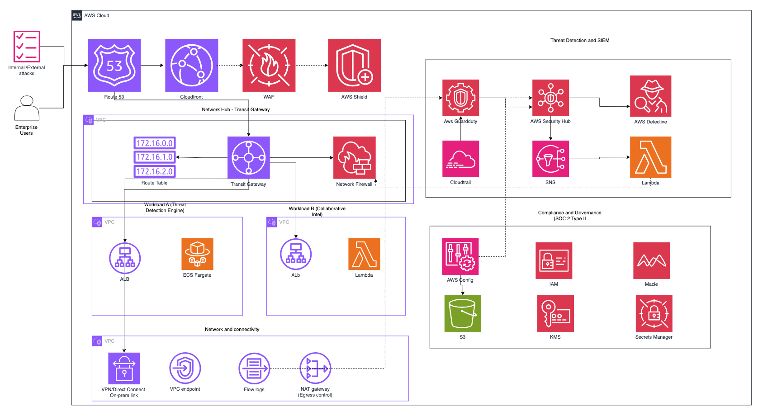
5. Outcomes & Impact
Metric | Result
SOC 2 Type II Compliance Achieved | Infrastructure delivered an audit-grade security environment enabling ZeroShield.ai to achieve SOC 2 Type II certification — a foundational requirement for its enterprise customer base.
90% Reduction in Manual Security Configuration | Replacing fragmented, manually managed security controls with an automated, policy-driven architecture eliminated the overhead that had previously made security operations slow and error-prone.
80% Improvement in Threat Response Time | GuardDuty and Security Hub together reduced the mean time to detect and respond to threats, giving the ZeroShield.ai security team unified, real-time visibility across their entire environment.
Centralised Network Control | Shift to centralised network control via Transit Gateway and automated compliance monitoring via AWS Config eliminated the manual overhead that had previously made security operations slow and error-prone.
Scalable, Verifiably Secure Platform | The result is a scalable, verifiably secure infrastructure that supports ZeroShield.ai's mission of delivering autonomous threat defense — not just for its clients, but built into the platform itself.

The infrastructure delivered by Kiwi Koru Limited gave ZeroShield.ai a production-ready, audit-grade security environment on AWS. By replacing fragmented, manually managed controls with an automated, policy-driven architecture, the platform achieved SOC 2 Type II certification — a foundational requirement for its enterprise customer base.
The shift to centralised network control via Transit Gateway and automated compliance monitoring via AWS Config eliminated the manual overhead that had previously made security operations slow and error-prone. GuardDuty and Security Hub together reduced the mean time to detect and respond to threats, giving the ZeroShield.ai security team unified, real-time visibility across their entire environment.
The result is a scalable, verifiably secure infrastructure that supports ZeroShield.ai's mission of delivering autonomous threat defense — not just for its clients, but built into the platform itself.
6. About Kiwi Koru Limited
Kiwi Koru Limited is a cloud architecture and engineering consultancy helping technology companies design, build and operate scalable, resilient systems on AWS. We bring deep expertise in high-availability architecture, real-time data platforms, infrastructure governance, network security, and production infrastructure engineering.

